Project Proposal

*A Social Media Analysis of How Fans React to Major Events During the NFL Season*

Daniel Murran, x13114336, x13114336@student.ncirl.ie

BSc (Hons) in Computing

Data Analytics

25/10/17

# Objectives

This project will analyse how fans react to major events during the NFL season. I will do this by analysing multiple platforms such as Facebook, Twitter, Instagram, Reddit, Newspaper websites and team sites.

By looking at sentiments and reactions over multiple platforms it will allow me to have a border view of these sentiments. It will also allow me to see if there is a difference between sentiments over the multiple platforms. Combining the multiple platforms will give the data a more reliable view.

I plan on focusing my analysis on specific events during the season such as the NFL Super bowl and the NFL Draft, I will also analyse fan loyalties during game days and other events during the season.

After receiving my data and complying my analysis I will visualise the results of my project using a data visualization tool such as tableau to show my results.

[FLESH OUT]

# Background

American Football is Americans favourite past time. Last year's Super Bowl on CBS drew 111.9 million viewers, making it the third-most-watched broadcast in U.S history.

I too have a keen interest in the NFL. I have been a New York Giants fan from a young age and have ventured across the Atlantic on several occasions to watch the Giants in action.

(Max. 2 Pages)

# Technical Approach

When deciding to pick Data Analytics my specialisation for forth year I immediately started to research project ideas. I looked at websites such as Reddit, Kaggle, Quora and Trap for NCI to give myself an idea on how to research for my project.

I looked at ways to get data though the use of Web Scraping, APIs and social media pulling.

After researching the methods on how to get the data I needed to make a project viable I then looked into the topic I wanted to focus my project on. As mentioned above I have a keen interest in the NFL and I felt working on something I had an interest in would benefit my project overall.

The value of storing volumes of data depends on our ability to extract useful reports, spot interesting events and trends, support decisions and policy based on statistical analysis and inference, and exploit the data to achieve business, operational, or scientific goals.

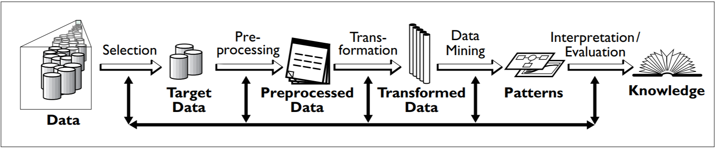

-Research

CHECK TRAP

# Special Resources Required

If applicable, e.g., books, hardware, etc.

# Project Plan

Below is a Gantt chart for to set out a guide line for myself to stay on top of deliverables, self-learning and project milestones.

# Technical Details

Implementation language and principal libraries

# Evaluation

Describe how you will evaluate the system with real technical data using system tests, integration tests etc. In addition, where possible describe how you will evaluate the system with an end user.

_____________________

Signature of student and date